Chicken & Stuffing Casserole

Ingredients:
- box Stove Top Stuffing (Chicken Flavor)
- boneless Chicken Breasts
2 cans Campbell’s Chicken Gravy
Morton’s “Nature Seasons” seasoning blend

Directions:
Boil chicken breasts (until done). Shred or cut into small pieces.
Prepare Stove Top Stuffing (as directed on box)
Spray Pam in 8X 8 casserole dish.
Spread stuffing on bottom of dish
Spread chicken pieces on top of stuffing
Sprinkle “Nature’s Seasons” seasoning on top of chicken
Pour gravy over chicken (to cover the chicken)

Cover and freeze.

OR to make a larger casserole:

2 boxes stuffing
3-4 boneless chicken breasts
3 cans gravy

Then I had it cooking at 350 degrees for 45-60 minutes (until hot in the center)

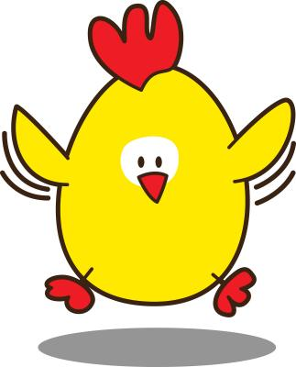

Chicken & Stuffing Casserole

Ingredients: chicken breasts, stove top stuffing, chicken gravy, seasoning.
Defrost in refrigerator overnight. For larger casserole, bake in pre-heated 350 for 45-50 minutes until hot in the center. For individual casserole, 8 x 8, bake in pre=heated oven for 30 – 35 minutes.

